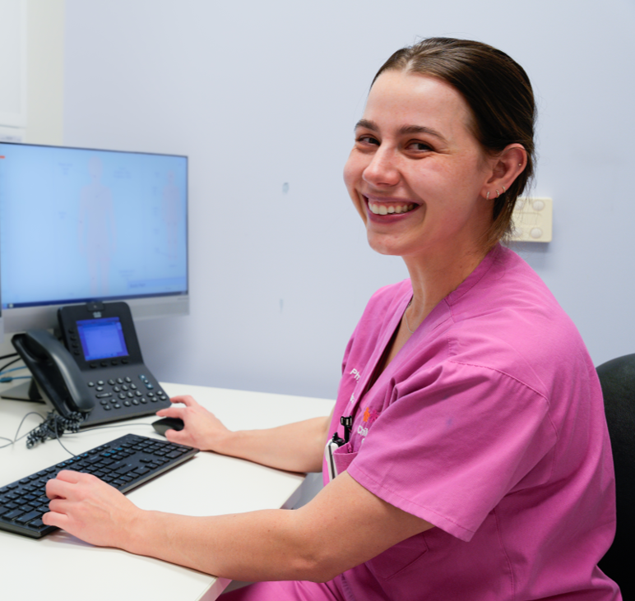

Allied Health Research Careers Development Individual Assessment Pack

Allied Health Research Careers Development Framework

#### Acknowledgement of Country

The Office of the Chief Allied Health Officer acknowledges the Traditional Custodians of the land on which we work. We pay our respect to the Aboriginal and Torres Strait Islander Elders past, present and emerging.

Allied Health Research Careers Development Individual Assessment Pack

Published by the State of Queensland (Queensland Health), August 2024

© State of Queensland (Queensland Health) 2024

[88x31](http://creativecommons.org/licenses/by-nc-nd/2.5/au/)

This work is licensed under a Creative Commons Attribution Non-Commercial No Derivatives V4.0 International licence.

You are free to copy and communicate the work in its current form for non-commercial purposes, as long as you attribute the State of Queensland, Queensland Health and comply with the licence terms. If you alter the work, you may not share or distribute the modified work. To view a copy of this licence, visit [https://creativecommons.org/licenses/by-nc-nd/4.0/deed.en](https://creativecommons.org/licenses/by-nc-nd/4.0/deed.en%20%20%20%20)

For copyright permissions beyond the scope of this licence contact: Intellectual Property Officer, Queensland Health, email [ip_officer@health.qld.gov.au](mailto:ip_officer@health.qld.gov.au), phone (07) 3708 5069.

For more information contact:

Office of the Chief Allied Health Officer,   
PO Box 2368, Fortitude Valley BC, Qld, 4006   
email allied_health_advisory@health.qld.gov.au, phone (07) 3328 9298.

An electronic version of this document is available at <https://www.health.qld.gov.au/hpresearch>

**Disclaimer**: The content presented in this publication is distributed by the Queensland Government as an information source only. The State of Queensland makes no statements, representations or warranties about the accuracy, completeness or reliability of any information contained in this publication. The State of Queensland disclaims all responsibility and all liability (including without limitation for liability in negligence) for all expenses, losses, damages and costs you might incur as a result of the information being inaccurate or incomplete in any way, and for any reason reliance was placed on such information.

Contents

Introduction 4

Instructions 5

**For individuals** 5

**For Leaders and Mentors** 6

Self-Assessment Mapping Tool 7

**Domain 1: Research knowledge and skills** 8

**Domain 2: Research impact and translation** 9

**Domain 3: Clinical and healthcare research context** 10

**Domain 4: Research leadership and strategy** 11

**Domain 5: Research capacity building and mentorship** 12

Spider Diagram 13

Allied Health Research Careers Development Framework Individual Action Plan 14

Case Studies 19

**Case Study 1 – Clinician Researcher** 19

**Case Study 2 – Research Fellow** 21

# Introduction

The Queensland Health Allied Health Research Careers Development Framework aims to describe the unique capabilities of allied health clinicians engaged in research, translation of research into practice, and research leadership across the diverse and developing roles of the Queensland Health clinical and research environment.

This Individual Self-Assessment pack is designed to develop a profile of your capabilities across five core domains that are important for allied health to deliver high-quality research and research translation across different practice settings, at entry and advancing practice levels, and across different roles in Queensland Health:

1. **Research knowledge and skills**: The technical knowledge and skills required to do research across all stages of the study lifecycle, from planning to dissemination.
2. **Research impact and translation**: The capabilities related to ensuring research is translated into practice and has an impact on society. This may be through evidence-based practice, knowledge translation, and embedding impact in the design and conduct of clinical research.
3. **Clinical and healthcare research context**: The unique capabilities required to conduct research in a clinical or healthcare context, including ensuring research projects are embedded appropriately in the context.
4. **Research leadership and strategy**: This domain includes those capabilities required to lead research strategy, research projects and programs, or teams which include research staff.
5. **Research capacity building and mentorship:** This domain includes capabilities related to building research capacity in researchers and healthcare staff, including one-on-one mentorship, education and contributing to the structure of research.

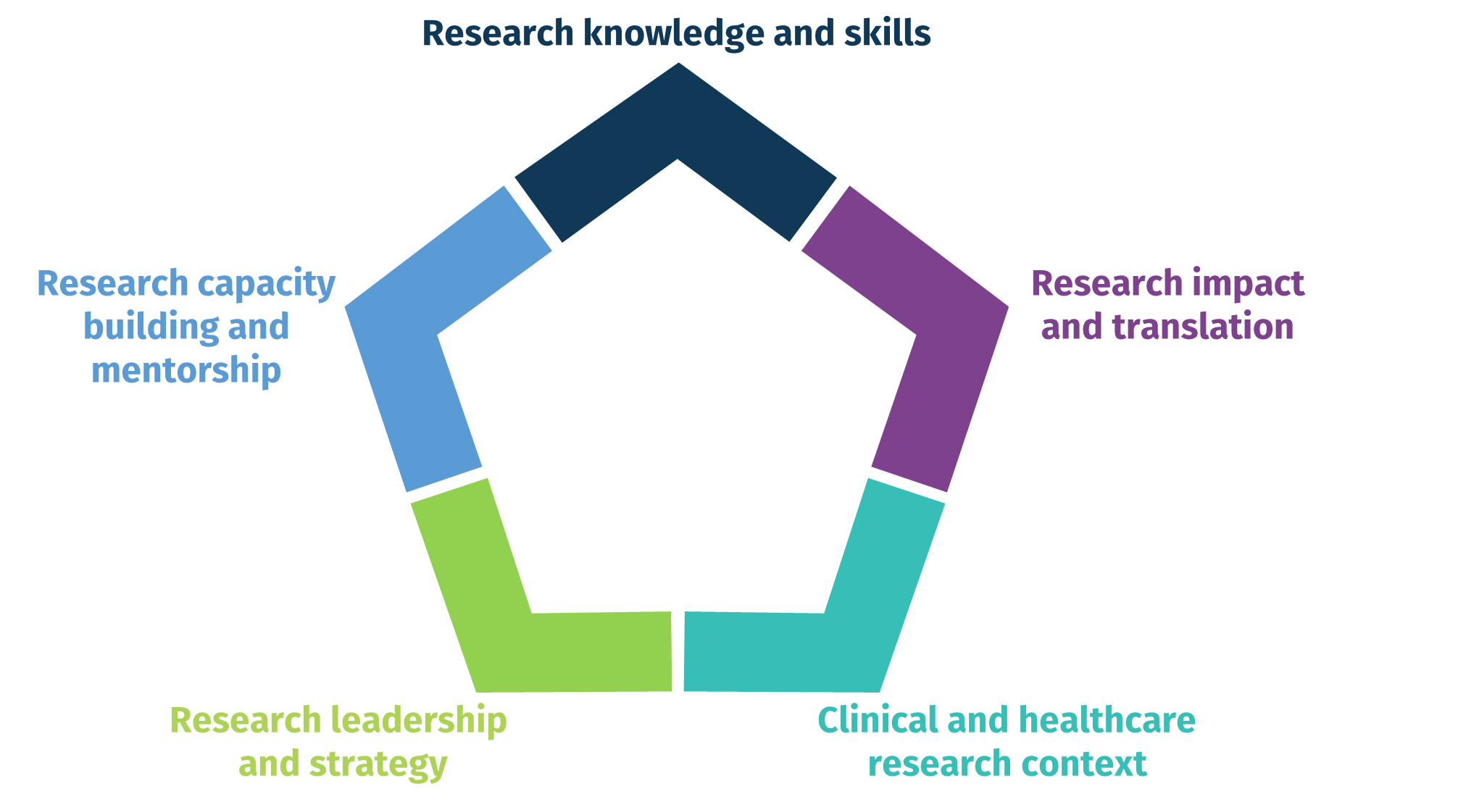

**Allied Health Research Careers Development Framework**

This tool is designed to be used both independently and in collaboration with your leader or manager to support performance development and career planning and identify opportunities for you to demonstrate and contribute your research capabilities in ways that make a meaningful contribution to organisational needs, goals and strategic priorities.

# Instructions

#### **For individuals**

1. **Understand the Framework**  
   Familiarise yourself with the Framework including the core domains and proficiency rating scale. Understand how each domain encapsulates a set of capabilities considered to be important for research and translation of research into practice within Queensland Health.
2. **Undertake Self-Assessment**  
   Conduct a self-assessment using the worksheets on pages xx – xx to assess your current proficiency across the different domains of research practice. This requires you to:
   1. Rate each capability statement in each domain using the proficiency rating scale
   2. Calculate the average overall score for each research domain
   3. Plot domain scores on Research Development Spider Diagram

This process should be an honest reflection of your capabilities with the aim to establish a baseline for your development journey.

1. **Identify service needs**  
   Consider the research maturity and needs of your current service context, and your role requirements (or intended role) and identify the research domains of practice and capabilities statements that may best add value to the organisation. If you’re not sure, discuss with your line manager or allied health leader. Record these on your Research Career Action Plan (pages xx-xx).
2. **Set development goals:**  
   Establish SMART (Specific, Measurable, Achievable, Relevant, Time-bound) developmental goals within relevant domains in consideration of your self-assessment outcomes, the needs of the service, and your role requirements to create a focused and relevant professional growth plan. Record these on your Research Career Action Plan.
3. **Develop action plan:**Develop an action plan outlining the steps needed to achieve your goals, considering activities like formal training, on-the-job learning, collaborative projects, and/or mentorship, etc.
4. **Collaborate with your Leader:**  
   Discuss your self-assessment and development plan with your leader and/or mentor to gain additional perspectives, refine your strategies, and help facilitate shared goal setting. Agree on appropriate and meaningful opportunities to contribute your capabilities to your service and organisation.

#### **For Leaders and Mentors**

1. **Understand the Framework**  
   Gain an understanding of the Framework to better facilitate its application across your team. Understand how each domain encapsulates a set of capabilities considered to be important for research and translation of research into practice within Queensland Health and consider how these may be applied and leveraged in your service context.
2. **Undertake Self-Assessment**  
   Facilitate and support team members in conducting their self-assessments to identify strengths and areas for growth within the context of the team and service goals, needs and development objectives.
3. **Identify service needs**  
   Consider the research maturity and needs of your current service context, and your team’s collective research skills to identify developmental needs and align service delivery with research capability enhancement. Identify how the research domains of practice and capabilities statements may best add value to the organisation and discuss with your team.
4. **Set development goals:**  
   Guide staff in setting their SMART (Specific, Measurable, Achievable, Relevant, Time-bound) developmental goals, ensuring they are aligned with individual aspirations, team objectives and service needs.
5. **Develop action plan:**Identify, share and support opportunities and resources that may support team members to formulate action plans that incorporate organisational resources and opportunities for development.
6. **Collaborate with your team:**  
   Provide feedback on team members’ self-assessments and development plans, offering guidance and mentorship to facilitate their growth. Identify and agree on appropriate and meaningful opportunities to contribute their unique capabilities to your service and organisation.

# Self-Assessment Mapping Tool

**Complete the following to identify your research capabilities relevant to Queensland Health research practice and roles  
a) Rate your proficiency on each capability statement**

Rate your proficiency for each capability statement using the 1-5 rating scale below (Note: you can score using 0.5 scale points if desired), and enter the number at the end of the row.

1. **No proficiency** – May have some awareness of the area but no experience or skill in the area and no ability to demonstrate capability.
2. **Emerging proficiency** - Gaining experience in the described knowledge and skills and starting to apply that knowledge to research activities and tasks. Requires support or mentoring to achieve outcomes.
3. **Consolidating proficiency** - Furthering skills and knowledge and can complete research activities or tasks independently. Requires guidance to deliver complex or advanced levels of activity or tasks.
4. **Advanced proficiency** - Becoming an expert in skill and knowledge required to demonstrate behaviour or activity. Able to apply skills and knowledge across a range of contexts and integrate expertise across domains. Able to support others in learning and applying knowledge, skills, and behaviour.
5. **Expert proficiency** - Acknowledged leader with in-depth knowledge and demonstrated strategic leadership in the area of knowledge, skill, or behaviour. Integrates, evaluates, and adapts knowledge, skills, or behaviour at an advanced level.

**b) Calculate overall domain scores:** Add together scores for all capability statements in each domain, and enter in the “total” cell. Then calculate the mean for each domain by dividing the total by the number of capability statements in that domain.

**c) Plot domain scores on Research Development Spider Diagram:** Plot the mean domain scores onto the spider diagram using a dot, then connect each dot to create a spider plot as a visual display of your capability profile.

**Example of a completed spider diagram**

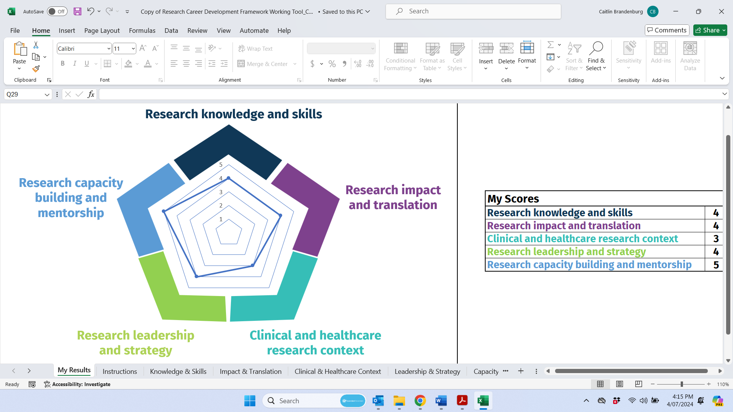

#### **Domain 1: Research knowledge and skills**

This domain reflects the technical knowledge and skills required to do research across all stages of the research study lifecycle, from planning to dissemination.

|  |  |  |
| --- | --- | --- |
| **Capability** | | **Score (1-5)**  **(0.5 scale allowed)** |
| 1. Understands general scientific principles of the research cycle and recognises different types of research methodologies and study types and designs | |  |
| 1. Understands the value of consumer/community involvement including co-design of research with consumers, and applies to appropriate research studies | |  |
| 1. Conducts literature searches and critically evaluates the literature to inform own research | |  |
| 1. Develops and implements research protocols, including articulating clear research questions/aims and selecting appropriate research methods and outcome measures | |  |
| 1. Understands and applies key concepts relating to research ethics, completing ethics applications, and research integrity | |  |
| 1. Understands and complies with local/international governance and regulatory requirements | |  |
| 1. Undertakes participant screening, recruitment, and consent procedures in an ethical manner according to the protocol | |  |
| 1. Accurately and safely collects, manages, stores, and disposes of research data | |  |
| 1. Plans, selects, and conducts appropriate data analysis and critically interprets results | |  |
| 1. Applies project management skills to coordinate study activities | |  |
| 1. Understands research funding landscape (including knowledge of a variety of funding sources), writes and applies for grants | |  |
| 1. Establishes revenue streams to support research through competitive grant funding or industry partnerships | |  |
| 1. Effectively disseminates research findings to scientific and non-scientific communities through presentations, publications and other mediums | |  |
| **Total** |  |
| **Mean (divide by 13)** |  |

#### **Domain 2: Research impact and translation**

This domain focuses on competencies related to ensuring research is translated into practice and has an impact on society. This may be through evidence-based practice, knowledge translation, and embedding impact in the design and conduct of clinical research.

|  |  |  |
| --- | --- | --- |
| **Capability** | | **Score (1-5)**  **(0.5 scale allowed)** |
| 1. Uses and promotes evidence-based practice in own setting | |  |
| 1. Promotes translation of research findings by engaging relevant stakeholders, including consumers, in the project lifecycle | |  |
| 1. Engages in dialogue and understands working with stakeholders including policymakers, professional organisations, consumer representatives, industry partners and government representatives | |  |
| 1. Understands different types of research impact and how research impact can be measured or reported | |  |
| 1. Engages in multidisciplinary knowledge exchange to enhance research impact | |  |
| 1. Participates in research that is close to practice with the potential for translation | |  |
| 1. Understands and applies knowledge translation methodology | |  |
| 1. Communicates research findings in an accessible way to diverse health system stakeholders | |  |
| 1. Produces research which informs the development of health policy | |  |
| **Total** |  |
| **Mean (divide by 9)** |  |

#### **Domain 3: Clinical and healthcare research context**

This domain includes the unique competencies required to conduct research in a clinical or healthcare context, including ensuring research projects are embedded appropriately in the context.

|  |  |  |
| --- | --- | --- |
| **Capability** | | **Score (1-5)**  **(0.5 scale allowed)** |
| 1. Maintains up-to-date knowledge of research and practice in their clinical area | |  |
| 1. Conducts research in the area of specialty practice | |  |
| 1. Applies healthcare and clinical knowledge to designing and conducting research, including developing practice-relevant research questions | |  |
| 1. Understands and interfaces research with other health service improvement processes (e.g., Quality improvement, healthcare innovation, evaluation, service, and workforce development) | |  |
| 1. Maintains a high level understanding of health systems at a local, national and/or international level | |  |
| 1. Brokers clinical and research expertise at a local, statewide, national and/or international level | |  |
| 1. Influences patient care by combining expert clinical and research skills | |  |
| 1. Generates innovative research-related ideas and puts them into action within clinical/healthcare area or organisation | |  |
| 1. Consults and collaborates with healthcare professionals, consumers, and other relevant health service staff to develop and conduct practice-relevant research appropriate to the healthcare setting | |  |
| 1. Navigates the interaction between healthcare and research roles including ethical complexities and governance requirements | |  |
| **Total** |  |
| **Mean (divide by 10)** |  |

#### **Domain 4: Research leadership and strategy**

This domain includes those competencies required to lead research strategy, research projects, or teams, including research staff.

|  |  |  |
| --- | --- | --- |
| **Capability** | | **Score (1-5)**  **(0.5 scale allowed)** |
| 1. Challenges traditional ways of thinking within area of research and/or clinical expertise | |  |
| 1. Understands the strategic landscape across research and healthcare and anticipates future directions and promising ideas | |  |
| 1. Contributes to or leads the development of research strategies and communicates strategy to the relevant stakeholders | |  |
| 1. Shapes and contributes to local policy and procedures | |  |
| 1. Promotes and supports good research practices and governance in line with relevant standards and legislation | |  |
| 1. Creates opportunities for and promotes the skills and research careers of others | |  |
| 1. Initiates, leads, and sustains research projects and/or a program of research | |  |
| 1. Establishes a reputation as a leader and drives agenda in research field | |  |
| 1. Serves on key research committees within their organisation and beyond (e.g., strategic advisory committees, grant review panels) | |  |
| 1. Promotes a culture of equity and opportunity for all staff engaged in research | |  |
| 1. Forms research teams that are fit for purpose (including consumers as appropriate), appropriately navigates team dynamics and creates a positive team culture | |  |
| 1. Establishes partnerships that enable the development of a clinical research workforce | |  |
| 1. Engages in effective research workforce planning and research budget management | |  |
| 1. Establishes, manages, and sustains research networks and collaborations across organisations to enhance the quality of research | |  |
| **Total** |  |
| **Mean (divide by 14)** |  |

#### **Domain 5: Research capacity building and mentorship**

This domain includes competencies related to building research capacity in researchers and healthcare staff, including one-on-one mentorship, education, and contributing to the structure of research.

|  |  |  |
| --- | --- | --- |
| **Capability** | | **Score (1-5)**  **(0.5 scale allowed)** |
| 1. Engages less experienced researchers with potential mentors and collaborators | |  |
| 1. Mentors and guides less experienced researchers | |  |
| 1. Seeks opportunities to engage staff in research and embed researchers into departments | |  |
| 1. Assists staff in identifying appropriate funding schemes and developing/writing targeted funding proposals | |  |
| 1. Supports staff through the research project lifecycle (e.g., literature search, data collection, data analysis) | |  |
| 1. Encourages and inspires staff in their research journey | |  |
| 1. Provides formal supervision associated with a research degree (e.g., honours, PhD) | |  |
| 1. Supports staff to develop their research careers and track record | |  |
| 1. Understands research training requirements and needs of the organisation | |  |
| 1. Supports and organises research learning opportunities for staff and other relevant stakeholders, such as consumers | |  |
| 1. Designs and delivers research training and development sessions and/or programs | |  |
| 1. Contribute to the strategy and structure of research mentoring/supervision in the organisation | |  |
| 1. Knows and uses different research-informed research development practices (e.g., teaching, education strategies, supervision, mentoring) | |  |
| 1. Undertakes evaluation and research on own research development activities (e.g., teaching, education strategies, supervision, mentoring) | |  |
| 1. Contributes to the promotion of research in the health service | |  |
| **Total** |  |
| **Mean (divide by 15)** |  |

**Allied Health Research Careers Development Framework**

# Spider Diagram

Completed by: ­­­_________________________________ Signature _________________________

Date: ____/______/______

# Allied Health Research Careers Development Framework Individual Action Plan

|  |  |
| --- | --- |
| **Action plan owner** | *Enter name of individual* |

|  |
| --- |
| **Aim of Action Plan** |
| *Describe the main aim/outcome of the action plan e.g.*   * *Support career development and opportunities for a new role (e.g. high lever, embedded research role, research leadership)* * *Enable identification of opportunities to contribute unique research capabilities to services and/or teams* * *Develop capabilities across research domains where skills or experience has been limited* |
|  |

|  |
| --- |
| **Service capabilities and needs** |
| *Describe the existing research capability of your team, service or organization and identify the research domains or specific capabilities that may support and enable the strategic priorities at a team, service, HHS, or broader level. Consider what is most important for your stakeholders. For example:*   * *Developing partnerships with academic institutions to support research projects, research higher degrees, and translation of research into practice in a service where there is high levels of local research expertise* * *Supporting clinicians to develop research projects in areas of high priority in a team where there is limited research expertise* * *Undertaking research in partnership with consumers for a new service that is being developed* * *Seeking research funding where the team is delivering a broad range of projects*   *Access the strategic plan (and other related plans as relevant, e.g. research plan, reform agenda) for your department, HHS, and broader Queensland Health to help identify needs and opportunities.* |
|  |

|  |
| --- |
| **SMART Goals** |
| *Describe the SMART goals this Action Plan aims to achieve. SMART goals are:*   * ***Specific:*** *The goal is clear and specific so you know exactly what you’re working towards.* * ***Measurable:*** *The goal and progress is able to measured so you know when the goal has been achieved.* * ***Achievable****: The goal is realistic and attainable.* * ***Relevant****: The goal is relevant to the direction you want your research career development to take.* * ***Time-bound****: The goal has clearly defined timeline, including a starting date and a target date.* |
| *1)* |
| *2)* |
| *3)* |
| *4)* |
| *5)* |

|  |  |  |
| --- | --- | --- |
| **SMART Goal Activities** | | |
| **Goal** | **Development Activities** | **Completed** |
| *SMART Goal from above* | *What activities will be undertaken to achieve the goal* | *Outcomes and reflections on completed activity* |
| *e.g. Develop mentoring skills in QI and research for at least three speech pathology team members in FY25* | * *Pre-meeting with SP Director re: department priorities* * *Observe mentoring/support session of HP Research Fellow* * *Literature review pilot/feasibility studies methodologies* | * *Meeting August – need to RV SP Op plan* |
|  |  |  |
|  |  |  |
|  |  |  |
|  |  |  |

|  |  |  |  |  |  |  |  |  |  |  |  |  |
| --- | --- | --- | --- | --- | --- | --- | --- | --- | --- | --- | --- | --- |
| **Research Careers Development Action Plan Timeline** | | | | | | | | | | | | |
| **Activity** | **Jan** | **Feb** | **Mar** | **Apr** | **May** | **June** | **July** | **Aug** | **Sept** | **Oct** | **Nov** | **Dec** |
| *Map activities from above across the year* |  |  |  |  |  |  |  |  |  |  |  |  |
| ***Goal 1-*** *Develop mentoring skills in QI and research for at least three speech pathology team members in FY25* | | | | | | | | | | | | |
| *Pre-meeting with SP Director re: department priorities* |  |  |  |  |  |  |  |  |  |  |  |  |
| *Observe mentoring/support session of HP Research Fellow* |  |  |  |  |  |  |  |  |  |  |  |  |
| *Literature review pilot/feasibility studies methodologies* |  |  |  |  |  |  |  |  |  |  |  |  |
|  |  |  |  |  |  |  |  |  |  |  |  |  |
|  |  |  |  |  |  |  |  |  |  |  |  |  |
| ***Goal 2-*** | | | | | | | | | | | | |
|  |  |  |  |  |  |  |  |  |  |  |  |  |
|  |  |  |  |  |  |  |  |  |  |  |  |  |
|  |  |  |  |  |  |  |  |  |  |  |  |  |

|  |  |  |  |
| --- | --- | --- | --- |
| **Endorsement** | | | |
| **Individual**  I agree to implement the documented action plan to the best of my ability and with support from my colleagues and leaders as required. | | | |
| Print Name |  | | |
| Signature: |  | Date: |  |
| **Manager/Lead (or Equivalent)**  I have read the Research Careers Development Action Plan and confirm that these activities will contribute to research capability development, and the service and/or Hospital and Health Service goals and that I support these activities. | | | |
| Print name |  | | |
| Signature: |  | Date: |  |

# Case Studies

The following case studies have been provided to illustrate how the current skills of two different types of allied health research positions map onto the Framework.

The Framework has been designed to allow individuals to represent their different capabilities and proficiency levels across all domains depending on their experience, and recognises that different role types will require different capability and proficiency levels across the domains. These cases illustrate this diversity but only represent each individuals’ unique circumstance. **There are many types of research roles which are not represented.**

#### **Case Study 1 – Clinician Researcher**

Case study 1 is a senior allied health clinician with over 20 years of clinical experience and an interest in research who currently holds a clinical leadership role.

In addition to their professional training, they have previously completed postgraduate training (Graduate Certificate in Clinical Redesign) and are currently undertaking a part-time PhD, conducted within the acute care health context. They described themself as follows: *“I would probably say I'm a clinician and I do research”.*

Figure 2 below illustrates how they rated their research capabilities in each domain on the Framework.

Figure 2. Case Study 1 – Clinician Researcher

For **Research Knowledge and Skills** this individual indicated an overall rating of 2 = Emerging Proficiency, reflecting the emergent level of academic researching training acquired to date from their first years of their PhD journey, stating: *“I wouldn't say I'm consolidating my research skills yet. I still feel like I'm in that earlier phase”.* At this point, they also felt they had had little opportunity yet to engage in **Research Impact & Translation** (rated 2 = Emerging Proficiency). They also rated themselves as a 2 in **Research Capacity Building and Mentorship** (rated 2 = Emerging Proficiency), commenting on how they used skills achieved so far to support staff through specific research stages in their role as clinical leader: *“I definitely feel like this is something I'm doing more of from a clinical perspective, you know, supporting and engaging or encouraging others to apply for grants or providing them some mentorship on certain things.””.*

Regarding **Clinician and Healthcare Research Context** they rated this as a 3 = Consolidating Proficiency, reflecting years of experience within the health context, prior post graduate training opportunities, and direct experience delivering activities focused on changing healthcare: *“I do think the grad cert clinical redesign definitely contributed to that. They did a lot on change management in that, so I would say definitely my clinical redesign experience contributed to my higher rating.”* Finally **Research Leadership and Strategy** was also rated 3 = Consolidating Proficiency, reflecting on their own leadership roles in health and how this influencing research leadership: *“I think it's the combination of being a very experienced clinician and I have a leadership role clinically, and now I've got some experience in research.”*

In an overall reflection on their ratings across the Framework, this individual commented on how their combined clinical and research skills influenced their ratings: *“…my clinical experience plays into my leadership in research…a lot of those skills translate. So as I pick up the research skills it's easier for me to provide that leadership and mentoring. I’ve still got a lot to learn from a research perspective, but that I already knew.”*

Completing the framework also identified multiple directions for further professional development and growth, for example: *“I know there's lots of research based [content] that I still need to learn in terms of methodology, analysis, that side of things”; “I think [skills in] dissemination at a policy level and at a higher executive sort of level….as much as I have some understanding of policy and procedure I’d benefit from some training on how to disseminate results from a policy framework perspective”, and; “I think if I was going to go on to do more supporting of research… more mentoring or formal supervision, then I feel like I'd need more training in that, but I can't see that necessarily occurring in the next two years”*

#### **Case Study 2 – Research Fellow**

Case study 2 is an allied health professional who is 8 years post completing a PhD. They have had minimal clinical practice experience, but have held multiple different research-related roles across University, health, and non-health sectors, using their clinical and research skills in various types of project positions. For the past few years they have worked as a Research Fellow within health, a role which has the responsibilities of building the research capacity and capability of the allied health workforce, as well as conducting their own research. They also hold an honorary position with a University. When asked, this individual described themself as: *“I would probably call myself a researcher rather than a clinician researcher as my clinical experience was so far in the past, so I usually describe myself as a researcher who operates within health services. I think in terms of my research career stage I'd be between early-career and mid-career stage.”*

Figure 3 below illustrates how they rated their research capabilities in each domain on the Framework.

Figure 3. Case Study 2 – Allied Health Research Fellow

Reflecting career stage and years of research activity and skill, as well as the health service context of this Framework, this person rated themself on both **Research Knowledge and Skills** and **Research Leadership and Strategy** as a 4 = Advanced Proficiency, stating: *“I have a fair amount of research experience but not to the level of an associate professor or professor. I feel like especially within health services, my level of experience is probably commensurate with a 4 whereas in a university it might look a little bit lower.”* **Research Capacity Building and Mentorship** was also rated as a 4 = Advanced Proficiency, reflecting years of experience supporting and mentoring clinical teams and consistent with the research capacity building role of their current position: *“most of my roles within the last eight years have involved a heavy research capacity building expectation, and I've done research in this field. [Although] I've never supervised a PhD or masters student to completion, I've had a lot of experience mentoring clinicians and supervising other research qualifications like medical registrar projects.”*

In comparison, **Research Impact & Translation** and **Clinical and Healthcare Research Context** were rated as a 3 = Consolidating Proficiency, and identified as areas for targeted development. In particular this individual commented on how the tool helped them re-consider their own personal assessment of their skills within the impact and translation domain, stating: *“I think impact and translation stood out [for me], as I would have rated myself higher in translation, but once I saw some of those items I realised I had a ways to go in some of those areas. It helped identify some specific targets for improvement.”* In the area of Clinical and Healthcare Research Context, this individual also recognized the drawbacks of their limited clinical experience in comparison to those who have worked extensively in the health system, stating: *“My clinical experience is really minimal so it makes sense that I've scored lower here. I certainly have experience doing research within health systems but am learning many things indirectly. I’m never going to have that experience from the coalface that clinicians have”*

When reflecting on the use of the tool to map their current capabilities, this individual commented: *“It definitely showed I need to develop more in the impact and translation space, and in a related sense in the clinical and healthcare context. Although I'm not a clinician, there are certainly ways in which I can develop skills in that clinical research nexus, certainly more knowledge of the health care system, health care funding models and things like that”.* They also noted the unique nature of this tool and health services as a context needing particular capabilities: *“I think it's useful to be able to map and show all of the skills I have beyond just the traditional research knowledge and skills, methodology type skills. I think research roles in health services really need to be looking across all of these categories much more so than university roles.”* Finally, important considerations were raised regarding finding training and supports that would help with the specific skill development needs of those who bridge both clinical and academic contexts: *“I know there's leadership programs available through Queensland health and even through the universities, but I've always wondered if they'd be fit for purpose for the type of leadership that I do in my roles. A lot of the training I have has been experiential or observing how my leaders do things.”*